Low-Level Design (LLD) — Auth Module
Attribute | Value
Module | Authentication & Password Management
Flows | Password login · OTP login · Forgot password · Reset password · Change password
Application | Complaint / Dealer Portal
Stack (target) | Core PHP + MySQL (PDO)
Stack (current repo) | Core PHP + PostgreSQL via PDO (pdo_obconn.php)
Document version | 1.0
Out of scope | SSO IdP integration (shares session helpers; separate entry points)

â”€â”€â”€â”€â”€â”€â”€â”€â”€â”€â”€â”€â”€â”€â”€â”€â”€â”€â”€â”€â”€â”€â”€â”€â”€â”€â”€â”€â”€â”€â”€â”€

1. Module Overview

1.1 Purpose
Provide secure authentication for portal users: username/password login (RSA-OAEP transport), email OTP login, forgot/reset password via one-time email link, and change password after login. Shared controls cover session lifecycle, remember-me, idle timeout, account lockout, password strength/history, and session_version revocation.

1.2 Scope
In scope | Out of scope
login.php password login | SSO (sso_login.php / callback) — brief note only
login-otp.php + verify-otp.php | RBAC permission admin UI
forgot-password.php + reset_password.php | User master CRUD
change_password.php + topbar modal | Mobile OTP
Lockout, remember-me, idle logout, session_version

1.3 High-level architecture
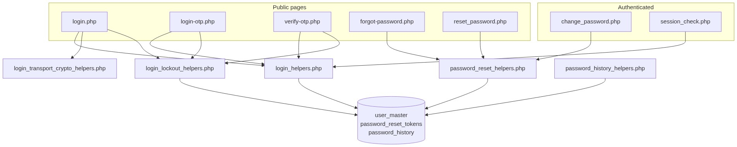
Figure 1 â€” High-level architecture
â”€â”€â”€â”€â”€â”€â”€â”€â”€â”€â”€â”€â”€â”€â”€â”€â”€â”€â”€â”€â”€â”€â”€â”€â”€â”€â”€â”€â”€â”€â”€â”€

2. Functional Requirements
ID | Requirement | Priority
FR-01 | Password login with RSA-OAEP encrypted password POST | Must
FR-02 | Optional remember-me (30 days) with HMAC cookie + session_version | Must
FR-03 | OTP request by username → email 6-digit OTP (10 min TTL) | Must
FR-04 | OTP verify with lockout on failures; 60s resend cooldown | Must
FR-05 | Forgot password by email → one-time reset link (60 min) | Must
FR-06 | Reset password with strength + last-3 history rules | Must
FR-07 | Change password after login (current + new + confirm) | Must
FR-08 | 5 failed attempts → lock 15 minutes; unlock email after 30 min | Must
FR-09 | Idle timeout 20 minutes (server + client) | Must
FR-10 | Password change/reset bumps session_version (revokes other sessions) | Must
FR-11 | Soft-deleted users cannot authenticate | Must
FR-12 | Logged-in users visiting auth pages redirect to index.php | Should
FR-13 | Change password success forces re-login on current browser | Must

â”€â”€â”€â”€â”€â”€â”€â”€â”€â”€â”€â”€â”€â”€â”€â”€â”€â”€â”€â”€â”€â”€â”€â”€â”€â”€â”€â”€â”€â”€â”€â”€

3. User Roles & Permissions

3.1 RBAC module slug
None for public auth pages. Authenticated app pages use normal RBAC after session_check.php.

3.2 Permission matrix
Resource | Access
login / OTP / forgot / reset | Public (guest)
logout.php | Any session
change_password.php | Authenticated ($_SESSION['usr_name']); POST only
api/password_history_check.php | Session or valid reset token
api/session_idle_touch.php | Authenticated
App pages with session_check.php | Authenticated + idle + session_version + page RBAC

3.3 Page / API mapping
Resource | Gate
login.php, login-otp.php, verify-otp.php, forgot-password.php, reset_password.php | Guest
change_password.php | Session required
api/password_history_check.php | Session or reset token
api/session_idle_touch.php / api/session_tab_logout.php | Session
cron/login_lockout_notify.php | CLI or HTTP cron key

3.4 After-market list scope
N/A (auth is user-account based, not after-market record scope).
â”€â”€â”€â”€â”€â”€â”€â”€â”€â”€â”€â”€â”€â”€â”€â”€â”€â”€â”€â”€â”€â”€â”€â”€â”€â”€â”€â”€â”€â”€â”€â”€

4. Business Rules
ID | Rule
BR-01 | Only user_master rows with deleted_at IS NULL authenticate.
BR-02 | Password login POST must use password_encrypted (RSA-OAEP); plaintext password not accepted.
BR-03 | 5 failures → lock 15 minutes; unknown username does not increment counters.
BR-04 | OTP stored in session (not DB); 6 digits; 10 min expiry; 60s resend.
BR-05 | Failed OTP verify counts toward same lockout counters.
BR-06 | Reset token: 32-byte hex; SHA-256 stored; 60 min; single-use; prior unused tokens invalidated.
BR-07 | New password: ≥8 chars, digit, upper, lower, special; not in last 3 history (+ not current).
BR-08 | Password update bumps session_version and records history.
BR-09 | Remember-me cookie embeds session_version; mismatch clears cookie.
BR-10 | Idle 20 min; session cookie lifetime 8 hours.
BR-11 | Change password destroys current session and redirects to login with success flash.
BR-12 | Forgot password currently discloses if email exists in system.

â”€â”€â”€â”€â”€â”€â”€â”€â”€â”€â”€â”€â”€â”€â”€â”€â”€â”€â”€â”€â”€â”€â”€â”€â”€â”€â”€â”€â”€â”€â”€â”€

5. Database Design

5.1 ER diagram
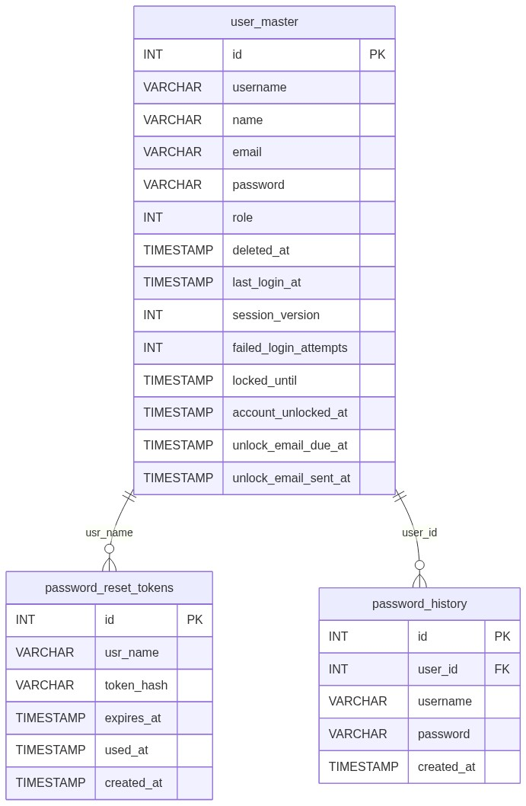
Figure 2 â€” Entity relationship diagram

5.2 Table: user_master (auth columns)
Column | MySQL type | Notes
id | INT UNSIGNED | PK
username | VARCHAR(100) | Login id
name | VARCHAR(150) | Display
email | VARCHAR(150) | OTP / forgot
password | VARCHAR(255) | password_hash
role | INT | Session role
deleted_at | TIMESTAMP NULL | Soft-delete
last_login_at | TIMESTAMP NULL | On success
session_version | INT NOT NULL DEFAULT 1 | Revocation
failed_login_attempts | INT NOT NULL DEFAULT 0 | Lockout
locked_until | TIMESTAMP NULL | Lock end
account_unlocked_at | TIMESTAMP NULL | Auto-unlock
unlock_email_due_at | TIMESTAMP NULL | Cron due
unlock_email_sent_at | TIMESTAMP NULL | Cron sent

5.3 Related tables
Table | Role
password_reset_tokens | Forgot/reset one-time links
password_history | Last 3 password hashes

5.4 Reference / lookup sources
Source | Usage
includes/keys/*.pem | RSA transport
PHP mail() | OTP / reset / unlock emails
Cron secret | Lockout notify HTTP

â”€â”€â”€â”€â”€â”€â”€â”€â”€â”€â”€â”€â”€â”€â”€â”€â”€â”€â”€â”€â”€â”€â”€â”€â”€â”€â”€â”€â”€â”€â”€â”€

6. API / Backend Design

6.1 Page endpoints
Endpoint | Method | Auth | Description
login.php | GET/POST | Guest | Password login
login-otp.php | GET/POST | Guest | Request OTP
verify-otp.php | GET/POST | Guest + OTP session | Verify / resend OTP
forgot-password.php | GET/POST | Guest | Request reset link
reset_password.php | GET/POST | Guest + token | Set new password
reset-password.php | GET | — | Alias → forgot
change_password.php | POST | Logged in | Change password
logout.php | GET | Any | Destroy session (+ SSO if active)

6.2 JSON APIs
Endpoint | Purpose
POST api/password_history_check.php | Pre-check new password vs history
POST api/session_idle_touch.php | Touch / enforce idle
api/session_tab_logout.php | Destroy session (204)

6.3 Supporting lookup APIs
N/A beyond password history check.

6.4 Core PHP module responsibilities
File | Role
includes/login_helpers.php | Session start/destroy, OTP, remember-me, session_version, idle
includes/login_lockout_helpers.php | Failures, lock, unlock, email schedule
includes/login_transport_crypto_helpers.php | RSA decrypt / key load
includes/password_reset_helpers.php | Forgot/reset/change process
includes/password_security_helpers.php | Hash / verify
includes/password_history_helpers.php | History check / record
includes/security_headers_helpers.php | CSP / headers on auth pages
cron/login_lockout_notify.php | Unlock + unlock emails

â”€â”€â”€â”€â”€â”€â”€â”€â”€â”€â”€â”€â”€â”€â”€â”€â”€â”€â”€â”€â”€â”€â”€â”€â”€â”€â”€â”€â”€â”€â”€â”€

7. Validation Rules

7.1 Server-side
Flow | Messages (selected)
Login | Invalid username or password · lockout messages
OTP request | Username is required. · Invalid username · No registered email found for this user. · Failed to send OTP. Please try again.
OTP verify | Invalid or expired OTP. Please try again. · resend cooldown
Forgot | Email address is required. · Please enter a valid email address. · Email address does not exist in the system.
Reset / Change | Strength messages · Confirm Password must match New Password. · New password cannot be same as your last 3 passwords · Current password is incorrect. (change)

7.2 Client-side
Script | Page
js/login_validation.js | Login (+ RSA encrypt)
js/login_otp_validation.js | OTP request
js/verify_otp_validation.js | OTP verify
js/forgot_password_validation.js | Forgot
js/reset_password_validation.js | Reset (+ history API)
js/change_password_validation.js | Change modal
js/session_idle_logout.js | Authenticated idle

â”€â”€â”€â”€â”€â”€â”€â”€â”€â”€â”€â”€â”€â”€â”€â”€â”€â”€â”€â”€â”€â”€â”€â”€â”€â”€â”€â”€â”€â”€â”€â”€

8. UI Screen Specifications

8.1 Listing
N/A.

8.2 Form panels / pages
Page | Fields
Login | Username*, Password* (encrypted), Remember me
Login OTP | Username*
Verify OTP | 6-digit OTP*, Resend
Forgot | Email*
Reset | New Password*, Confirm*
Change modal | Current*, New*, Confirm*

8.3 Details
N/A.

8.4 Modals
Modal | Host
Change Password | includes/change_password_modal.php via topbar.php

â”€â”€â”€â”€â”€â”€â”€â”€â”€â”€â”€â”€â”€â”€â”€â”€â”€â”€â”€â”€â”€â”€â”€â”€â”€â”€â”€â”€â”€â”€â”€â”€

9. Database Flow

9.1 Create / update (password change or reset)
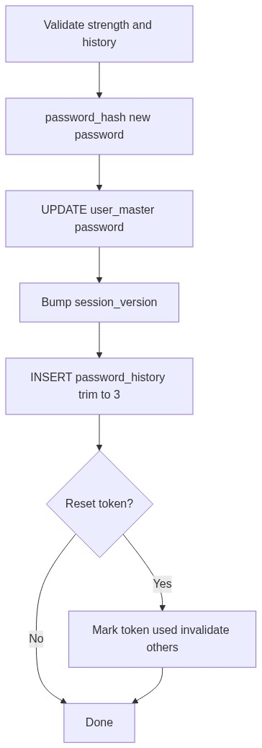
Figure 3 â€” Create database flow

9.2 Soft-delete
Users soft-deleted via User Admin; auth queries require deleted_at IS NULL.

9.3 List query pattern
N/A. Auth lookups are by username/email:
SELECT ... FROM user_master
WHERE TRIM(username) = :usr
AND deleted_at IS NULL;
â”€â”€â”€â”€â”€â”€â”€â”€â”€â”€â”€â”€â”€â”€â”€â”€â”€â”€â”€â”€â”€â”€â”€â”€â”€â”€â”€â”€â”€â”€â”€â”€

10. Sequence Diagram

10.1 Password login
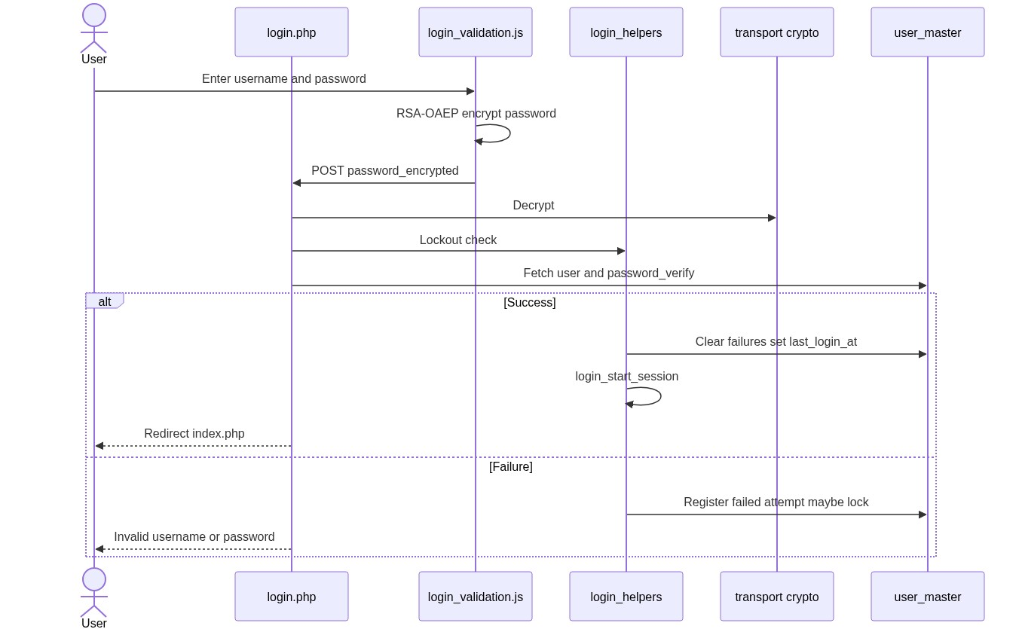
Figure 4 â€” Sequence: Create / update on Spare Parts page

10.2 OTP login
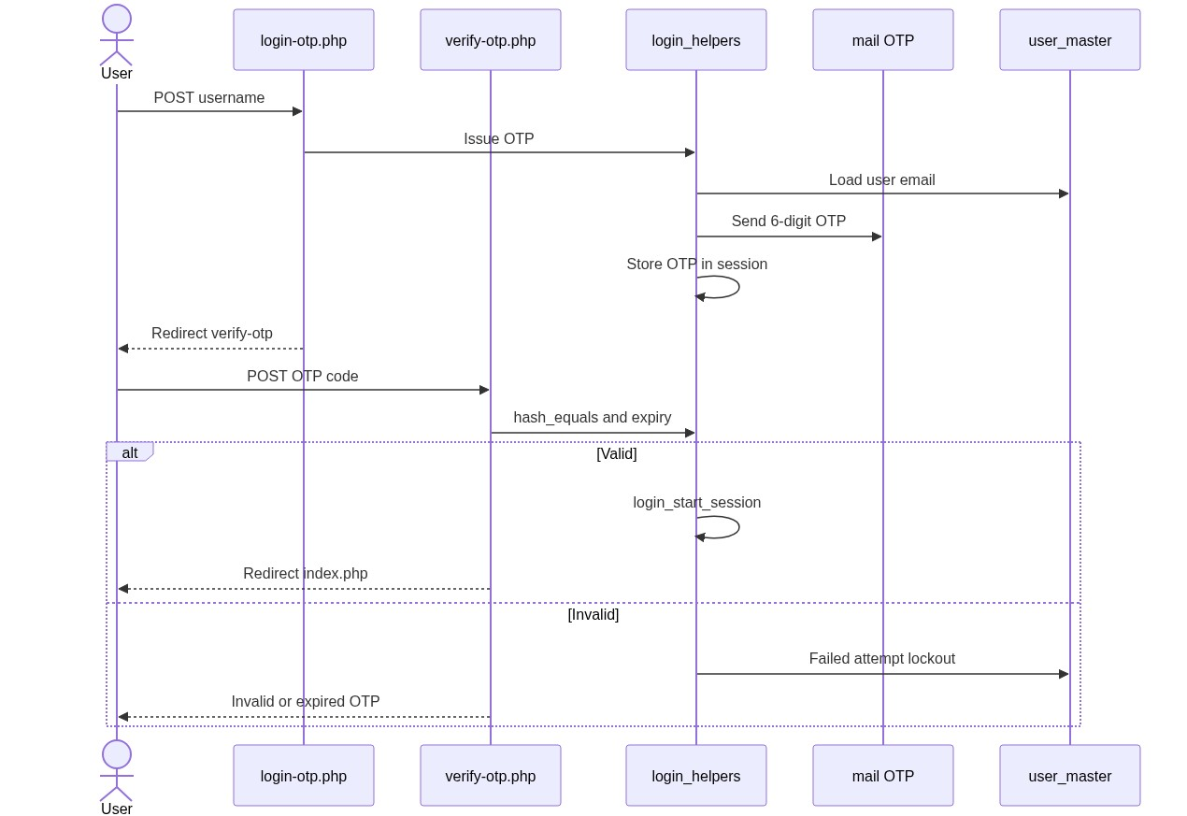
Figure 5 â€” Sequence: Add Spare Parts from IB / SL row
â”€â”€â”€â”€â”€â”€â”€â”€â”€â”€â”€â”€â”€â”€â”€â”€â”€â”€â”€â”€â”€â”€â”€â”€â”€â”€â”€â”€â”€â”€â”€â”€

11. Activity Diagram
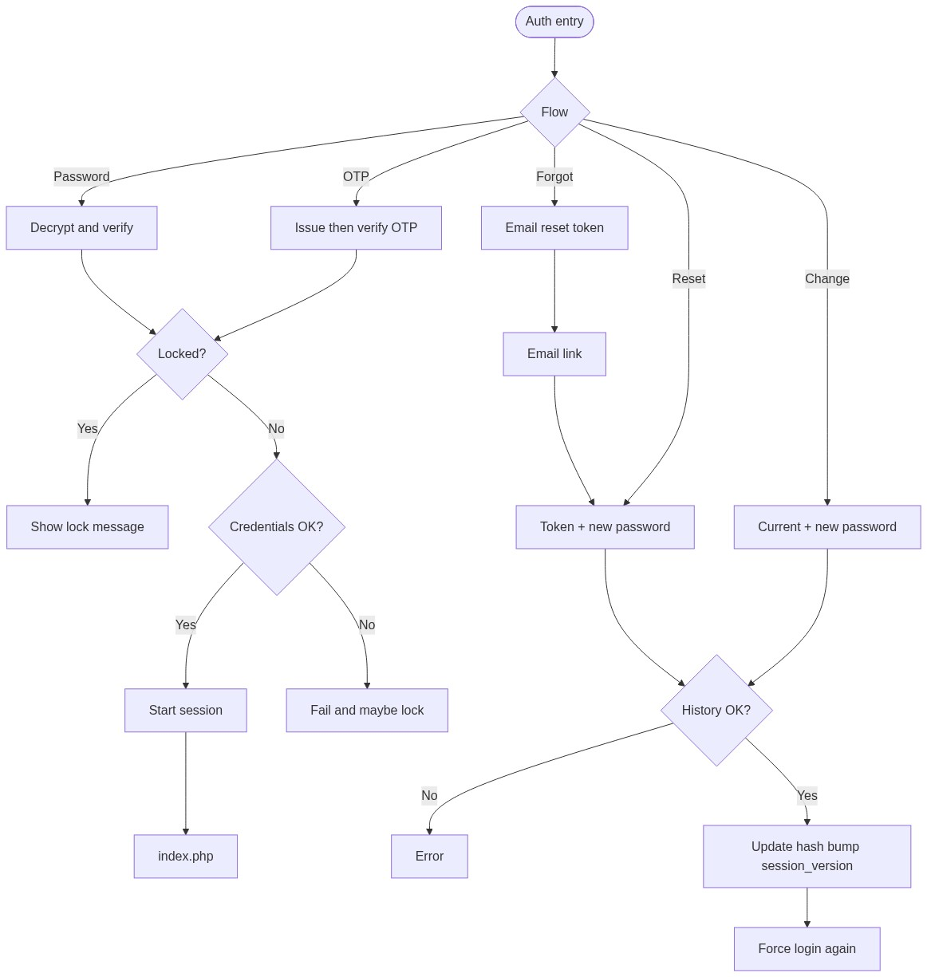
Figure 6 â€” Activity diagram
â”€â”€â”€â”€â”€â”€â”€â”€â”€â”€â”€â”€â”€â”€â”€â”€â”€â”€â”€â”€â”€â”€â”€â”€â”€â”€â”€â”€â”€â”€â”€â”€

12. Class / Module Diagram
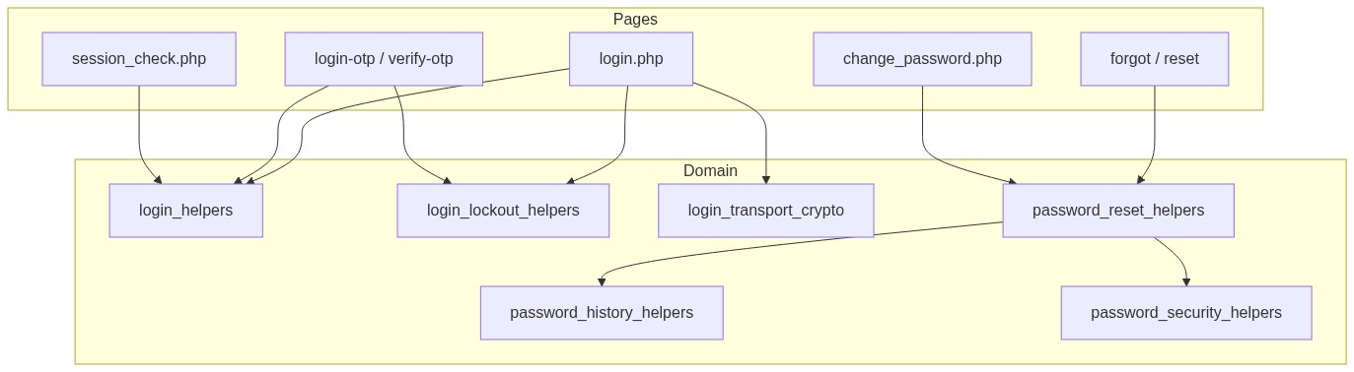
Figure 7 â€” Class / module diagram

12.1 Key functions
Function | Role
login_start_php_session() | Cookie + security headers
login_start_session() | Stamp session keys + regenerate id
login_destroy_session() | Clear session + remember cookie
login_decrypt_transport_password() | RSA-OAEP decrypt
login_issue_otp() / verify helpers | OTP lifecycle
login_remember_* | Remember-me cookie
login_enforce_session_version() | Revocation
Lockout helpers | Fail / lock / unlock / email due
password_reset_process_forgot/reset/change | Password flows
password_history_* | Last-3 reuse check

â”€â”€â”€â”€â”€â”€â”€â”€â”€â”€â”€â”€â”€â”€â”€â”€â”€â”€â”€â”€â”€â”€â”€â”€â”€â”€â”€â”€â”€â”€â”€â”€

13. Folder Structure
ComplaintManagement/
├── login.php
├── login-otp.php
├── verify-otp.php
├── logout.php
├── forgot-password.php
├── reset_password.php
├── reset-password.php
├── change_password.php
├── session_check.php
├── api/
│ ├── password_history_check.php
│ ├── session_idle_touch.php
│ └── session_tab_logout.php
├── includes/
│ ├── login_helpers.php
│ ├── login_lockout_helpers.php
│ ├── login_transport_crypto_helpers.php
│ ├── password_reset_helpers.php
│ ├── password_security_helpers.php
│ ├── password_history_helpers.php
│ ├── change_password_modal.php
│ ├── security_headers_helpers.php
│ └── keys/
│ ├── login_transport_public.pem
│ └── login_transport_private.pem
├── js/
│ ├── login_validation.js
│ ├── login_otp_validation.js
│ ├── verify_otp_validation.js
│ ├── forgot_password_validation.js
│ ├── reset_password_validation.js
│ ├── change_password_validation.js
│ ├── password_history_check.js
│ └── session_idle_logout.js
├── cron/
│ └── login_lockout_notify.php
├── sql/
│ ├── add_user_master_login_lockout.sql
│ └── add_user_master_session_version.sql
└── docs/
└── LLD_Auth_Module.md
â”€â”€â”€â”€â”€â”€â”€â”€â”€â”€â”€â”€â”€â”€â”€â”€â”€â”€â”€â”€â”€â”€â”€â”€â”€â”€â”€â”€â”€â”€â”€â”€

14. Error Handling
Layer | Pattern
Auth pages | In-page / session flash messages
APIs | JSON {error} / {valid:false}
Lockout | Specific locked messages with remaining minutes
PDO failures on login | Generic Invalid username or password

14.1 Common messages
Message | When
Invalid username or password | Bad password login
Your account is locked... | Lockout active
Invalid username | OTP unknown user
No registered email found for this user. | OTP no email
Invalid or expired OTP. Please try again. | Bad OTP
Email address does not exist in the system. | Forgot unknown email
Invalid or expired reset link... | Bad reset token
New password cannot be same as your last 3 passwords | History
Current password is incorrect. | Change password
Password changed successfully. Please sign in again. | Change success
Password reset successfully. Please login with your new password. | Reset success
Your account details were updated. Please sign in again. | session_version revoke

â”€â”€â”€â”€â”€â”€â”€â”€â”€â”€â”€â”€â”€â”€â”€â”€â”€â”€â”€â”€â”€â”€â”€â”€â”€â”€â”€â”€â”€â”€â”€â”€

15. Security Considerations
Area | Control
Transport | RSA-OAEP for login password; HTTPS assumed for all
Password storage | password_hash / password_verify
Lockout | 5 / 15 min; unlock notify cron
Session | HttpOnly, SameSite=Lax, Secure, strict mode, regenerate on login
Idle | 20 min server + client
Revocation | session_version on password/critical user changes
Remember-me | HMAC-signed; version-bound
Reset tokens | Hashed at rest; single-use; expiry
Keys | PEM under includes/keys/ blocked by .htaccess
Enumeration | Login avoids user existence; forgot email currently enumerates
Open redirect | Change password redirect_to allowlisted
Headers | CSP / Permissions-Policy / X-Frame-Options on session start

â”€â”€â”€â”€â”€â”€â”€â”€â”€â”€â”€â”€â”€â”€â”€â”€â”€â”€â”€â”€â”€â”€â”€â”€â”€â”€â”€â”€â”€â”€â”€â”€

16. Audit Logs

16.1 Built-in field-level audit
Field / store | Behavior
last_login_at | Set on successful login
failed_login_attempts / locked_until | Lockout trail
account_unlocked_at / unlock email timestamps | Cron unlock
session_version | Implicit revocation counter
password_history | Prior password hashes
password_reset_tokens.used_at | Token consumption
Dedicated auth audit table | Not implemented

â”€â”€â”€â”€â”€â”€â”€â”€â”€â”€â”€â”€â”€â”€â”€â”€â”€â”€â”€â”€â”€â”€â”€â”€â”€â”€â”€â”€â”€â”€â”€â”€

17. Test Cases

17.1 Functional
ID | Scenario | Expected
TC-01 | Valid password login | Session + redirect index
TC-02 | Wrong password | Generic error; attempts increment
TC-03 | 5 failures | Locked 15 minutes
TC-04 | Remember-me login | Cookie set; restores session
TC-05 | OTP to user with email | Redirect verify; email sent
TC-06 | OTP wrong code | Error; attempts increment
TC-07 | OTP expiry / resend cooldown | Rejected / wait message
TC-08 | Forgot known email | Reset link issued
TC-09 | Forgot unknown email | Existence error
TC-10 | Reset with weak / reused password | Validation error
TC-11 | Reset success | Login flash; old sessions revoked
TC-12 | Change with wrong current | Error
TC-13 | Change success | Forced re-login; other sessions revoked
TC-14 | Idle 20 min | Session expired → login
TC-15 | Soft-deleted user | Cannot login
TC-16 | Decrypt failure | Treated as invalid credentials

â”€â”€â”€â”€â”€â”€â”€â”€â”€â”€â”€â”€â”€â”€â”€â”€â”€â”€â”€â”€â”€â”€â”€â”€â”€â”€â”€â”€â”€â”€â”€â”€

18. Assumptions & Dependencies

18.1 Assumptions
1. PHP OpenSSL available for RSA key ops.
2. mail() (or equivalent) delivers OTP / reset / unlock emails.
3. HTTPS in production so cookies Secure and password forms are protected.
4. Lockout cron scheduled after unlock events.
5. SSO is optional and out of scope for this document.

18.2 Dependencies
Dependency | Purpose
user_master | Accounts
OpenSSL / Web Crypto | Login transport
Password history table | Reuse prevention
Cron runner | Unlock emails
jQuery / validate.js | Client validation

â”€â”€â”€â”€â”€â”€â”€â”€â”€â”€â”€â”€â”€â”€â”€â”€â”€â”€â”€â”€â”€â”€â”€â”€â”€â”€â”€â”€â”€â”€â”€â”€

Appendix A — Success / flash messages
Event | Message
OTP resent | OTP has been sent to your registered email address.
Reset success | Password reset successfully. Please login with your new password.
Change success | Password changed successfully. Please sign in again.
Session revoked | Your account details were updated. Please sign in again.

â”€â”€â”€â”€â”€â”€â”€â”€â”€â”€â”€â”€â”€â”€â”€â”€â”€â”€â”€â”€â”€â”€â”€â”€â”€â”€â”€â”€â”€â”€â”€â”€

Appendix B — Select2 control map
N/A for Auth forms (standard inputs / OTP digits).
â”€â”€â”€â”€â”€â”€â”€â”€â”€â”€â”€â”€â”€â”€â”€â”€â”€â”€â”€â”€â”€â”€â”€â”€â”€â”€â”€â”€â”€â”€â”€â”€

Appendix C — Timing constants
Constant | Value
Session cookie / login stamp lifetime | 8 hours
Idle timeout | 20 minutes
Remember-me | 30 days
OTP TTL | 10 minutes
OTP resend cooldown | 60 seconds
Lockout threshold | 5 failures
Lock duration | 15 minutes
Unlock email delay | 30 minutes after unlock
Reset token TTL | 60 minutes
Password history depth | 3

â”€â”€â”€â”€â”€â”€â”€â”€â”€â”€â”€â”€â”€â”€â”€â”€â”€â”€â”€â”€â”€â”€â”€â”€â”€â”€â”€â”€â”€â”€â”€â”€

Appendix D — Flow summary
Password login --> session --> app
OTP login --> email OTP --> session --> app
Forgot --> email link --> reset_password --> login
Change password --> update hash + session_version --> destroy session --> login
â”€â”€â”€â”€â”€â”€â”€â”€â”€â”€â”€â”€â”€â”€â”€â”€â”€â”€â”€â”€â”€â”€â”€â”€â”€â”€â”€â”€â”€â”€â”€â”€
End of LLD — Auth Module

